|  |
| --- |
| AIC, MATHEMATICS LEARNING AREA  **YEAR 12 MATHEMATICS APPLICATIONS – UNIT 3**  **Assessment Type: Response - 6%**  **TASK 1 - TEST 1 –** **Term 4, Week 9**  **CALCULATOR-FREE SECTION**  **Syllabus Content:** 3.1.1 – 3.1.9  Bivariate data analysis: Identifying and describing associations, fitting a linear model to numerical data, association and causation |

Student Name: __________________________________________

ID: _______ Date: _______

**TIME ALLOWED: 50 minutes** under test conditions

**MATERIAL REQUIRED / RECOMMENDED FOR THIS PAPER:**

*TO BE PROVIDED BY THE SUPERVISOR*

Question/answer booklet.

*TO BE PROVIDED BY THE CANDIDATE*

*Standard Items:* pens, pencils, pencil sharpener, highlighter, eraser, ruler.

**IMPORTANT NOTE TO CANDIDATES**

No other items may be taken into the examination room. It is **your** responsibility to ensure that you do not have any unauthorised notes or other items of a non-personal nature in the examination room. If you have any unauthorised material with you, hand it to the supervisor **before** reading any further.

**Structure of this paper**

|  |  |  |  |  |
| --- | --- | --- | --- | --- |
| Section | Number of questions available | Number of questions to be attempted | Suggested working time (minutes) | Marks available |
| **Calculator Free** | **4** | **4** | **20** | **21** |
| **Calculator Assumed** | **3** | **3** | **30** | **24** |
|  | | | **Marks available:** | **/45** |
| **Task Weighting** | 6% |

**Instructions to candidates**

* The rules for the conduct of this examination are detailed in the booklet *WACE* *Examinations*

*Handbook*. Sitting this examination implies that you agree to abide by these rules.

* Answer the questions in the spaces provided.
* Spare answer pages can be used. If you need to use them, indicate in the original answer space where the answer is continued.

Question 1 (6 marks)

A student recorded the time taken and the number of correct answers made when completing nine multiple choice tests, each with $20$ different questions, in the table below.

|  |  |  |  |  |  |  |  |  |  |
| --- | --- | --- | --- | --- | --- | --- | --- | --- | --- |
| Time, $t$ minutes | $$11$$ | $$8$$ | $$10$$ | $$9$$ | $$15$$ | $$7$$ | $$4$$ | $$13$$ | $$12$$ |
| Number correct, $c$ | $$14$$ | $$15$$ | $$17$$ | $$14$$ | $$17$$ | $$12$$ | $$10$$ | $$18$$ | $$16$$ |

(a) Construct a scatterplot of this data on the axes below. (2 marks)

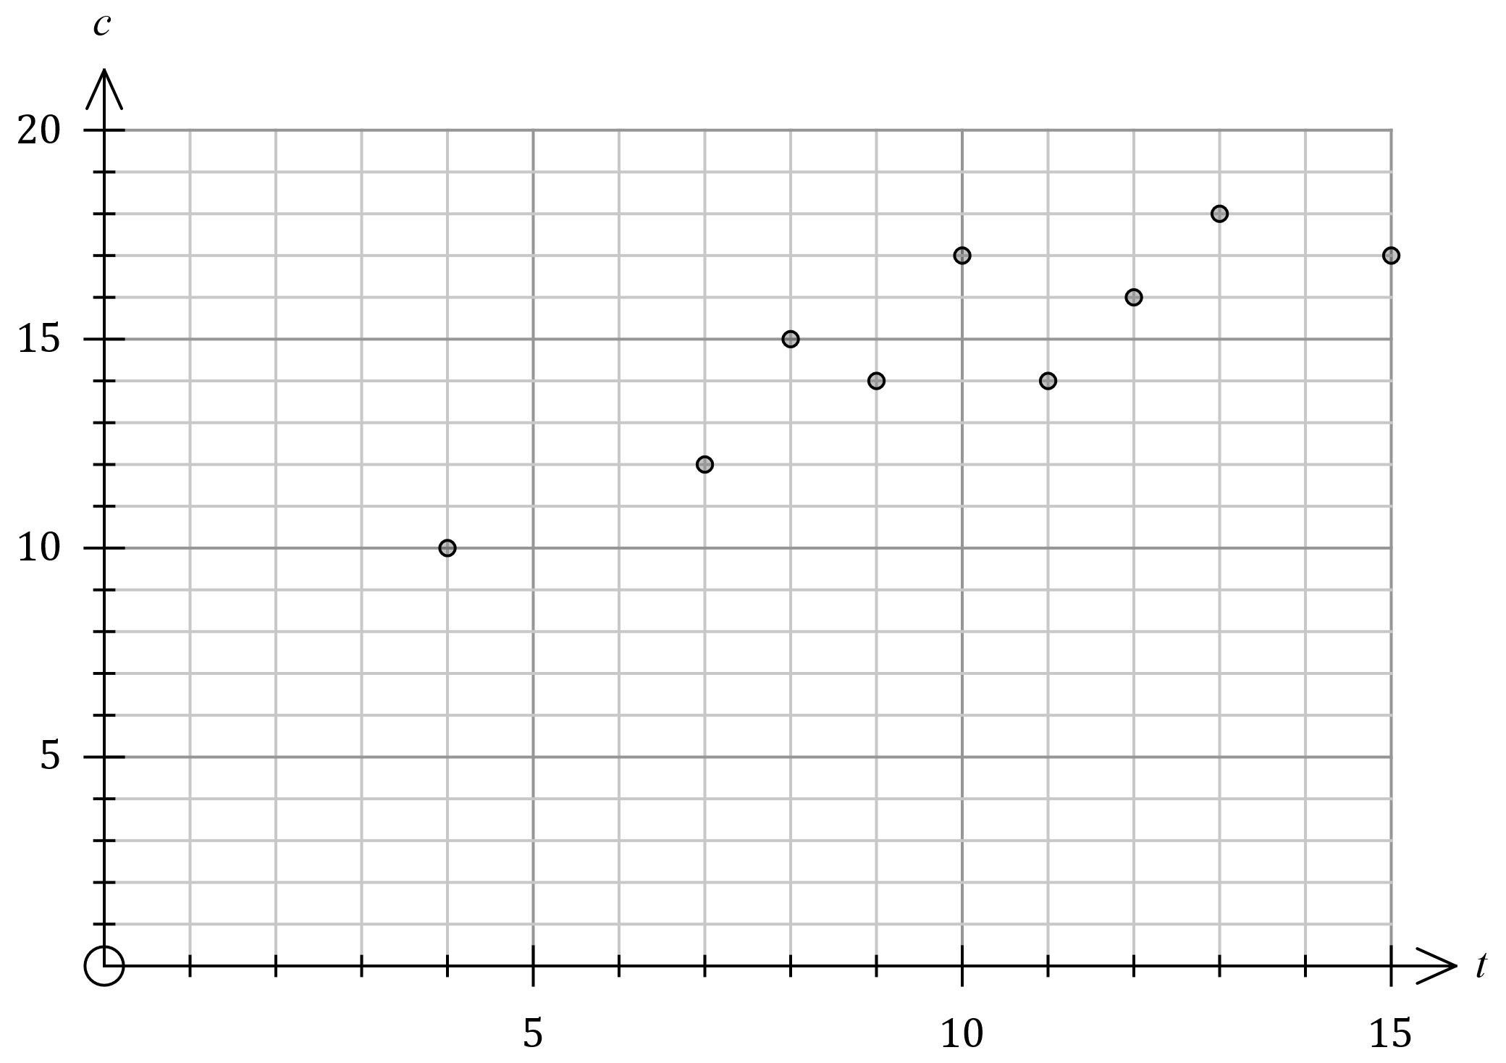

|  |
| --- |
| **Solution** |
| See graph |
| **Specific behaviours** |
| Correctly plots  ü at least $5$ points  ü all points |

(b) Describe the strength and direction of the association between the two variables.

(2 marks)

|  |
| --- |
| **Solution** |
| The association is strong and positive. |
| **Specific behaviours** |
| ü describes strength as moderate or strong  ✓ describes direction as positive |

(c) The student used the data to conclude that taking more time to answer multiple choice tests caused them to answer more questions correctly. Explain whether this conclusion is justified. (2 marks)

|  |
| --- |
| **Solution** |
| There is not enough evidence to conclude that there is a causal relationship between the variables. An observed association does not always imply a causal relationship, as there may be other factors involved. |
| **Specific behaviours** |
| ü indicates causal relationship not justified  ✓ states observed association does not always imply causal relationship |

Question 2 (7 marks)

Bivariate data analysis of the mass $M$ g, length $L$ mm and width $W$ mm of a large number of snap peas yielded the following correlation coefficients and least-squares lines:

$$r_{WL}=0.8, L=4W+3, r_{ML}=0.7, L=15M+6.$$

(a) Determine the percentage of the variation in the lengths of these snap peas that can be explained by the variation in their masses. (2 marks)

|  |
| --- |
| **Solution** |
| $$r_{ML}^{2}={0.7}^{2}=0.49$$ $49\%$ of the variation. |
| **Specific behaviours** |
| ü chooses relevant coefficient  ✓ squares and states percentage |

(b) One of the least-squares lines would be better than the other as a predictor for the lengths of these snap peas. Write the equation of the line below and explain your choice.

(2 marks)

|  |
| --- |
| **Solution** |
| $$L=4W+3$$ The association between width and length is stronger than between mass and length. |
| **Specific behaviours** |
| ü chooses and writes relevant line  ✓ explains using strength of association |

(c) Use the equation from part (b) to predict the length of a snap pea that has a mass of $7$ g and a width of $27$ mm. (1 mark)

|  |
| --- |
| **Solution** |
| $$L=4\left(27\right)+3=111 \text{mm}$$ |
| **Specific behaviours** |
| ü calculates length |

(d) Explain why it is difficult to comment on the validity of the prediction made in part (c).

(2 marks)

|  |
| --- |
| **Solution** |
| Reasonably strong association between the variables supports the validity. However, there is no way of telling if the prediction involves extrapolation, and extrapolation would invalidate the prediction. Hence difficult to comment. |
| **Specific behaviours** |
| ü indicates strength of association supports validity  ü indicates no data to check for extrapolation |

Question 3 (6 marks)

The scatterplot below shows data from $25$ samples drawn from different suburbs in a city. The variables are the percentage of people in each sample who have grey hair ($x$) and who have heart disease ($y$).

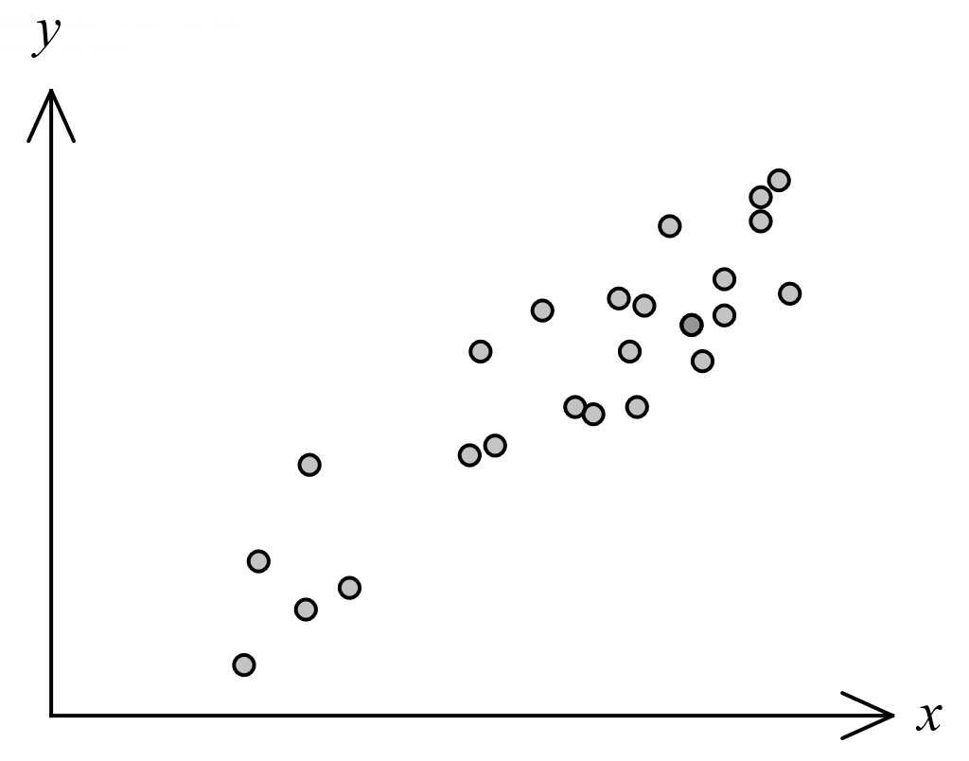

(a) The correlation coefficient $r_{xy}$ for this data is one of $0.9, 0.6, 0.3, -0.3, -0.6, -0.9$.  
State $r_{xy}$ and explain your choice. (2 marks)

|  |
| --- |
| **Solution** |
| $r_{xy}=0.9$- the association is positive and strong. |
| **Specific behaviours** |
| ü correct value  ✓ explains using direction and strength |

(b) The least-squares line for the data is $y=ax+b$, where $a$ and $b$ are constants.

(i) State the name of the response variable for this least-squares line. (1 mark)

|  |
| --- |
| **Solution** |
| Response variable is heart disease, or $y$. |
| **Specific behaviours** |
| ü states name or variable |

(ii) Explain whether the variable $a$ would be a positive or negative number. (1 mark)

|  |
| --- |
| **Solution** |
| $a$ would be a positive number as association is positive. |
| **Specific behaviours** |
| ü states positive with reason |

(c) Identify and explain a possible non-causal explanation for the observed association between the variables in this data. (2 marks)

|  |
| --- |
| **Solution** |
| The age of people in each sample may be a confounding variable. The two variables are more likely to have a causal association with age rather than with each other. |
| **Specific behaviours** |
| ü states age or another confounding variable  ü explains common response to age |

|  |
| --- |
| **Alternative Solution** |
| The observed association may be coincidental. Coincidental associations more likely with smaller sample sizes, and here the sample is only $25$. |
| **Specific behaviours** |
| ü states coincidence  ü suitable explanation |

**Question 4 [2 marks]**

For the following set of axes, determine whether the variables have been placed on the correct axis.

(Circle Y for yes and N for no)

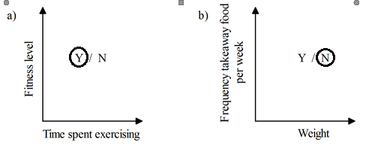

End of Non-Calc Section

|  |
| --- |
| AIC, MATHEMATICS LEARNING AREA  **YEAR 12 MATHEMATICS APPLICATIONS – UNIT 3**  **Assessment Type: Response - 6%**  **TASK 1 - TEST 1 –** **Term 4, Week 9**  **CALCULATOR-ASSUMED SECTION**  **Syllabus Content:** 3.1.1 – 3.1.9  Bivariate data analysis: Identifying and describing associations, fitting a linear model to numerical data, association and causation |

Student Name: __________________________________________

ID: _______ Date: _______

**TIME ALLOWED: 50 minutes** under test conditions

**MATERIAL REQUIRED / RECOMMENDED FOR THIS PAPER:**

*TO BE PROVIDED BY THE SUPERVISOR*

Question/answer booklet.

*TO BE PROVIDED BY THE CANDIDATE*

*Standard Items:* pens, pencils, pencil sharpener, highlighter, eraser, calculator, ruler.

**IMPORTANT NOTE TO CANDIDATES**

No other items may be taken into the examination room. It is **your** responsibility to ensure that you do not have any unauthorised notes or other items of a non-personal nature in the examination room. If you have any unauthorised material with you, hand it to the supervisor **before** reading any further.

**Structure of this paper**

|  |  |  |  |  |
| --- | --- | --- | --- | --- |
| Section | Number of questions available | Number of questions to be attempted | Suggested working time (minutes) | Marks available |
| **Calculator Free** | **4** | **4** | **20** | **21** |
| **Calculator Assumed** | **3** | **3** | **30** | **24** |
|  | | | **Marks available:** | **/45** |
| **Task Weighting** | 6% |

**Instructions to candidates**

* The rules for the conduct of this examination are detailed in the booklet *WACE* *Examinations*

*Handbook*. Sitting this examination implies that you agree to abide by these rules.

* Answer the questions in the spaces provided.
* Spare answer pages can be used. If you need to use them, indicate in the original answer space where the answer is continued.

Question 5 (8 marks)

The following table shows the compressive strength, in megapascals, achieved by concrete after one week for different water-cement ratios, as a percentage, used in its mixture.

|  |  |  |  |  |  |  |  |
| --- | --- | --- | --- | --- | --- | --- | --- |
| Water-cement ratio $R, \%$ | $$40$$ | $$43$$ | $$46$$ | $$49$$ | $$52$$ | $$57$$ | $$61$$ |
| Strength $S$, MPa | $$27.6$$ | $$28.1$$ | $$26.3$$ | $$25.1$$ | $$25.1$$ | $$22.6$$ | $$20.3$$ |

(a) Determine the equation of the least-squares line for the data, with ratio $R$ as the explanatory variable. (2 marks)

|  |
| --- |
| **Solution** |
| $$S=-0.357R+42.78$$ |
| **Specific behaviours** |
| ü correct gradient (at least $2$ dp)  ü correct intercept (at least $2$ dp) |

(b) In the context of the question, interpret the slope of the least-squares line in part (a).

(2 marks)

|  |
| --- |
| **Solution** |
| For each $1\%$ increase in the water-cement ratio, the strength of the concrete decreases by $0.357$ MPa. |
| **Specific behaviours** |
| ü relates increase in ratio to decrease in strength  ✓ quantifies interpretation |

(c) State the coefficient of determination and use it to assess the strength of the linear association. (2 marks)

|  |
| --- |
| **Solution** |
| $r^{2}=0.943$. Since $94\%$ of the variation in strength can be explained by the variation in water-cement ratio, the linear association can be assessed as strong. |
| **Specific behaviours** |
| ü coefficient as decimal or percentage  ✓ states association is strong |

(d) Predict the value of the strength $S$ when the water-cement ratio is $55\%$ and discuss the validity of this prediction. (2 marks)

|  |
| --- |
| **Solution** |
| $$S=-0.357(55)+42.78=23.1 \text{MPa}$$ This prediction is valid since it does not involve extrapolation and the association is strong. |
| **Specific behaviours** |
| ü calculates strength  ✓ states prediction is valid with at least one reason |

Question 6 (8 marks)

Participants at a conference were categorised by district they worked in and main area of interest. The table below shows the number of participants in these categories.

|  |  |  |  |  |
| --- | --- | --- | --- | --- |
|  |  | Main area of interest | | |
|  |  | Technology | Science | Engineering |
| District | Metropolitan | $$36$$ | $$31$$ | $$19$$ |
| Regional | $$52$$ | $$66$$ | $$36$$ |

(a) Determine what percentage of participants

(i) had engineering as their main area of interest. (2 marks)

|  |
| --- |
| **Solution** |
| $$55÷240=22.9\%$$ |
| **Specific behaviours** |
| ü total number of participants  ✓ correct percentage |

(ii) worked in the metropolitan district. (1 mark)

|  |
| --- |
| **Solution** |
| $$86÷240=35.8\%$$ |
| **Specific behaviours** |
| ü correct percentage |

(b) Use the above table to complete the following table of row percentages, rounding entries to the nearest whole number. (3 marks)

|  |  |  |  |
| --- | --- | --- | --- |
| (%) | Technology | Science | Engineering |
| Metropolitan | $$42$$ | $$36$$ | $$22$$ |
| Regional |  |  |  |

|  |
| --- |
| **Solution** |
| See table |
| **Specific behaviours** |
| ü at least two correct entries  ✓ both rows add to $100$ ✓ all correct entries |

(c) Explain whether the percentaged table above suggest the presence of an association between district worked in and main area of interest for the participants. (2 marks)

|  |
| --- |
| **Solution** |
| Yes, an association is evident between the variables as the pairs of percentages in the columns for both technology and science are different. For example, $42\%$ of those who work metro have technology as main interest compared to only $34\%$ who work regional. |
| **Specific behaviours** |
| ü states association  ✓ explanation using different percentages |

Question 7 (8 marks)

The linear model fitted to a data set had equation $\hat{y}=15.65x-52.5$. The correlation coefficient between the variables was $r_{xy}=0.986$. The residual plot for the linear model is shown below.

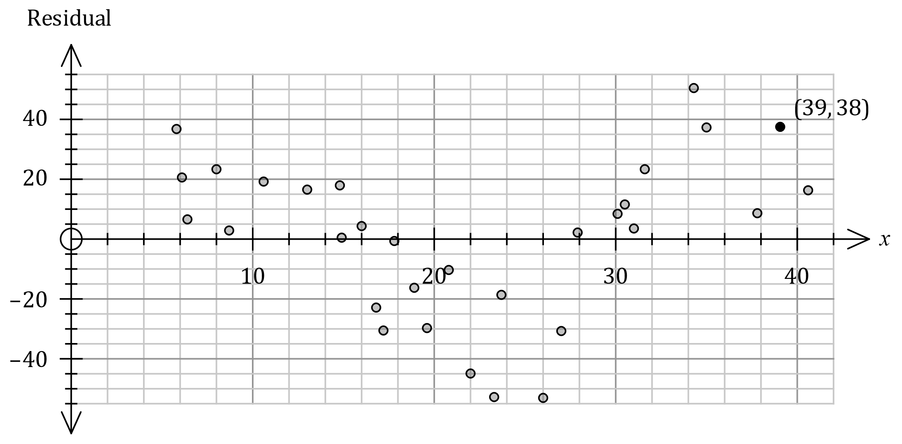

(a) The residual for the data point $(39, 596)$ is not shown. Determine the residual for this point and add it to the residual plot. (3 marks)

|  |
| --- |
| **Solution** |
| $$\hat{y}=15.65(39)-52.5=557.85$$ Residual: $596-557.85=38.15$. |
| **Specific behaviours** |
| ü calculates $\hat{y}$ ✓ calculates residual  ✓ plots residual |

(b) Use the residual plot to assess the appropriateness of fitting a linear model to the data.

(2 marks)

|  |
| --- |
| **Solution** |
| Linear model is not appropriate as a pattern is clearly evident in the residuals. |
| **Specific behaviours** |
| ✓ states that linear model is not appropriate  ü states a pattern evident in the residuals |

(c) The point shown on the plot above with a residual of $-44.8$ was derived from the data point $x=a, y=b$. Determine the value of $a$ and the value of $b$. (3 marks)

|  |
| --- |
| **Solution** |
| $a$ is the $x$-coordinate: $a=22$ $b$ is the $y$-coordinate: $$\hat{y}=15.65(22)-52.5=291.8$$ $$b-291.8=-44.8⇒b=247$$ |
| **Specific behaviours** |
| ü value of $a$ ✓ calculates $\hat{y}$ ✓ value of $b$ |

**End of test questions**

**EXTRA WORKING PAGE:**